**IP Subnetting – Fixed Length Subnet Mask (FLSM)**

**Question:**

Distribute this given IP Address **121.100.100.0/24** in 4 Labs, each lab should contain 54 PCs.

**IP Subnet Chart:**

**Solution:**

**Step1:**

Finding the number of Network bits. In this process we will borrow the bits from host side. We can find it with the help of subnet mask, we are given CIDR /24 it means subnet mask will be **255.255.255.0**.

Every octet consists of 8-bit in this case we are having 24 1’s in network bit.

11111111.11111111.11111111.0

As we know, every binary value having two possible values either 0 or 1. And with one binary we can make two value and with two binary values, we can make four values. And with three binary value, we can make 8 values and so on.

$2^{2}=4$ > **2 bits**

Here, we need to configure 4 subnets for this we need to borrow 2 bits and making the MSB of host bit of subnet mask to 1 and the value we will get,

**11111111.11111111.11111111.11000000**

**Step2:**

Calculating the updated subnet mask by converting above 4 octet’s bits in Decimal number, we will get,

(11000000)2 = (1 × 2)7 + (1 × 2)6 + (0 × 2)5 + (0 × 2)4 + (0 × 2)3 + (0 × 2)2 + (0 × 2)1 + (0 × 2)0 = 128 + 64 = (192)10

**255.255.255.192**

**Step3:**

Find the appropriate subnet size, calculate the closest power of 2 that is equal to or greater than 54.

**26 = 64**

No of useable Hosts:

26 = 64-2 = 62

**Step4:**

Determine the subnet ranges and addresses.

**Subnet 1:**

121.100.100.0/26, (Range: 121.100.100.0 - 121.100.100.63)

For this Subnet Network ID will be 121.100.100.0 and Broadcast Address will be 121.100.100.63

**Subnet 2:**

121.100.100.64/26, (Range: 121.100.100.64 - 121.100.100.127)

For this Subnet Network ID will be 121.100.100.64 and Broadcast Address will be 121.100.100.127

**Subnet 3:**

121.100.100.128/26, (Range: 121.100.100.128 - 121.100.100.191)

For this Subnet Network ID will be 121.100.100.128 and Broadcast Address will be 121.100.100.191

**Subnet 4:**

121.100.100.192/26, (Range: 121.100.100.192 - 121.100.100.255)

For this Subnet Network ID will be 121.100.100.192 and Broadcast Address will be 121.100.100.255

**Let’s Practical**

**Designed Topology:**

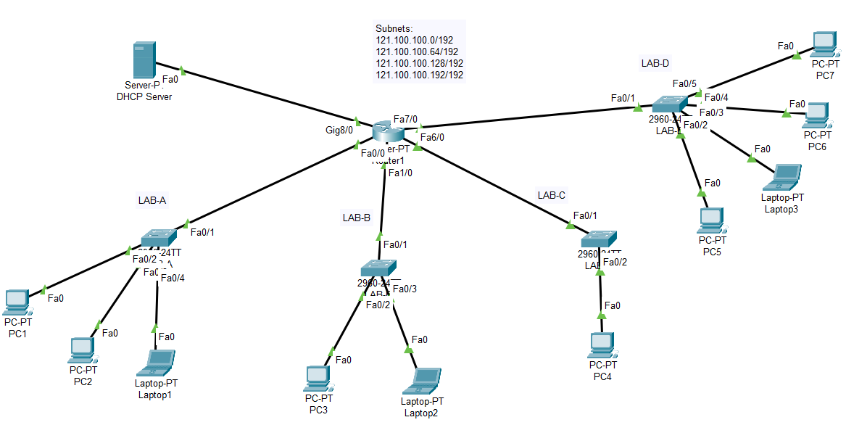

**Configuration of Router:**

Router>enable

Router#config terminal

Router(config)#hostname R1

R1(config)#int Fa0/0

R1(config-if)#ip address 121.100.100.62 255.255.255.192

R1(config-if)#no shutdown

R1(config-if)#exit

R1(config)#int Fa1/0

R1(config-if)#ip address 121.100.100.126 255.255.255.192

R1(config-if)#no shutdown

R1(config-if)#exit

R1(config)#int Fa6/0

R1(config-if)#ip address 121.100.100.190 255.255.255.192

R1(config-if)#no shutdown

R1(config-if)#exit

R1(config)#int Fa7/0

R1(config-if)#ip address 121.100.100.254 255.255.255.192

R1(config-if)#no shutdown

R1(config-if)#exit

R1(config)#int Gig8/0

R1(config-if)#ip address 192.168.10.254 255.255.255.0

R1(config-if)#no shutdown

R1(config-if)#exit

**Assigning IP Address to DHCP Server:**

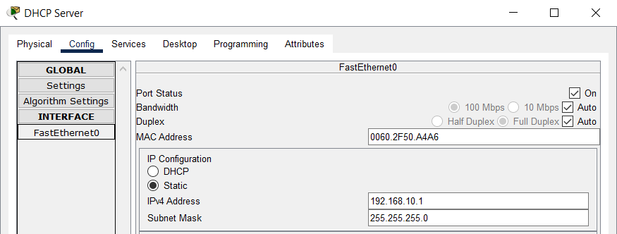

**Assigning Default-gateway to DHCP Server:**

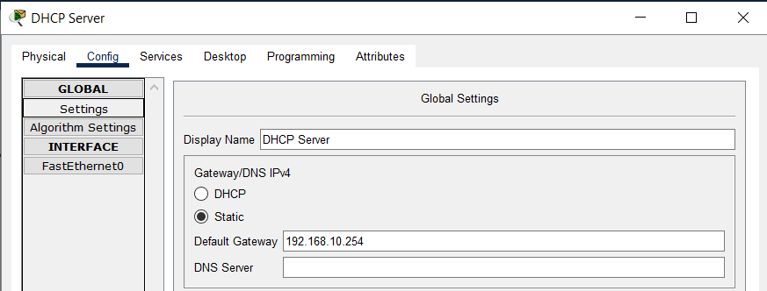

**Creating DHCP Pools:**

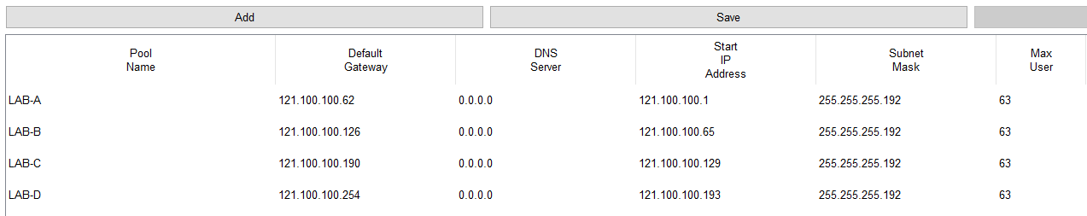

Now you can assign IP addresses to different PCs of different Labs by using DHCP (Dynamic Host Configuration Protocol) Method. Let’s assign the IP Address to one PC/Laptop of each Lab.

**IP Configuration of PC1:**

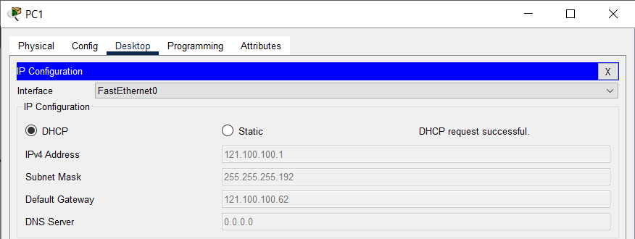

**IP Configuration of PC3:**

**IP Configuration of PC4:**

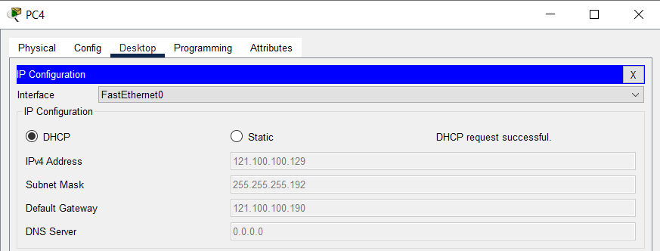

**IP Configuration of PC5:**

**Checking connectivity by pinging form Laptop1 to PC5:**

